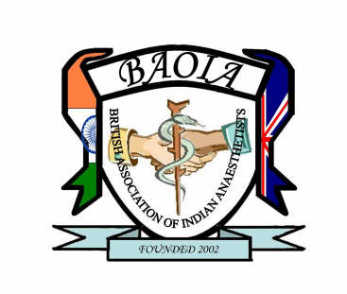
Update in Anaesthesia & Perioperative Medicine
British Association of Indian Anaesthetists
CALL FOR ABSTRACTS for 2023

The Annual Scientific Meeting will be held at the Manufacturing & Technology Centre, Coventry, on 6th October 2023.

This call is unrestricted, however prizes will be awarded to trainees only.
Deadline for submissions
5pm on 20th August 2023 in word format by email to abstract.asm@gmail.com

Submitting an Abstract – Guidance notes

All submitted abstracts will be assessed and ranked. The top six abstracts will be chosen for oral presentation and will be judged on the day of the prizes. If you wish to have your work presented as poster only, you must specify at the time of submission. All posters will be judged on the day for the prizes.

Abstract should include

- Title, authors (identifying speaker and grade), employing institution
- Introduction/Methods/Results/Discussion or Conclusion
- Abstracts should be no more than 300 words in length (excluding the title, authors and up to 3 references)
- Maximum 1 table or a graph or a figure can be in included
- Results must be included in the abstract, rather than just "results will be presented"
- No smaller than Arial Font 10 point.
- Include whether your submission has been previously presented anywhere (this is generally acceptable providing results are still recent)
- You may submit more than one abstract, providing all work is distinct from each other

Late submissions will be rejected.

In submitting an abstract you confirm that you, or the presenting author, will register and pay to attend the conference.

The abstracts will be judged by a panel. The corresponding author will be notified by 23rd August 2023, by email.

